- (a) What are the errors that come across in testing Hypothesis? 3 Marks

Error in testing of hypothesis: TYPE I AND TYPE II ERRORS
In the context of testing of hypotheses, there are basically two types of errors we can make.

We may reject H0 when H0 is true this is Type I error and is denoted by (alpha α) known as (alpha) error, and We may accept H0 when in fact H0 is not true which is Type II error. Type II error is denoted by β (beta) known as ß error. e)
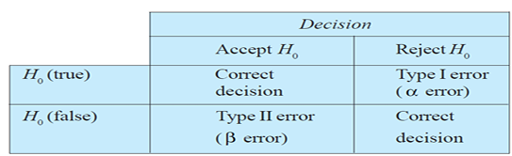

(b) Discuss role of Statistics in Business Management? 7 Marks

Role of Statistics in Business Management
Certain activities of a typical organization where Statistics plays an important role in their execution are discussed below
Marketing
Before a product is launched, the market research team of an organization, through a pilot survey, makes use of various techniques of statistics to analyze data on population, purchasing power, habits of the customers, competitors, pricing etc. such studies reveal the possible market potential for the product to be launched.

Production
Statistical methods are used to carry out R&D programs for the improvement in the quality of the existing products and setting quality control standards for new ones. Decisions about the quantity and time of either self-manufacturing or buying from out-side are based on statistically analyzed data

Finance
A statistical study through correlation analysis of profits and dividends helps to predict and decide probable dividends for future years. Statistics, applied to analysis of data, on assets and liabilities and income and expenditure helps to ascertain the financial results of various operations.
Financial forecasts, break-even analysis, investment decisions under uncertainty all involve the application of relevant statistical methods for analysis.

Personnel
In the process of manpower planning, a personnel department makes statistical studies of wage rates, incentive plans, cost of living, labor turnover rates, employment trends, accidents rates, performance appraisal and training and development programs. Employer-employee relationships are studied by statistically analyzing various factors such as wages, grievances handling, welfare, delegation of authority, education and housing facilities, and training and development.

(c) The following distribution gives the pattern of overtime work done by 100 employees of a company. Calculate the average overtime work done per employee. (STEP DEVIATION METHOD) 10 Marks
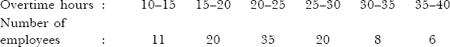

- (a) Define Coefficient of correlation with example? 3 Marks
The coefficient of correlation,is a number that indicates the strength (magnitude) and direction of statistical relationship between two variables.
Family income and expenditure on luxury items.
A statistical technique that is used toanalyze the strength and direction of the relationship between two quantitative variables, is called correlation analysis

(b) The probability that a pen manufactured by a factory be defective is 1/10. If two such pens are manufactured . what is the probability that exactly two are defective ? 7 Marks

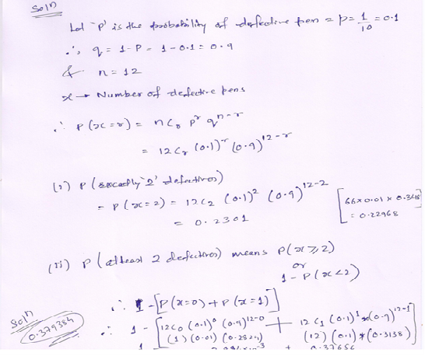

(c) Ten competitors in a beauty contest are ranked by three judges in the following order: 10 Marks
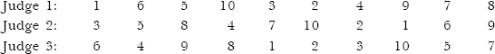 Use the rank correlation coefficient to determine which pair of judges has the nearest approach to
common tastes in beauty

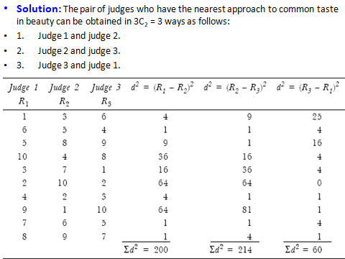
- (a) Define Time series and its uses? 3 Marks
A time series is a set of numerical values of some variable obtained at regular period over time. The series is usually tabulated or graphed in a manner that readily conveys the behavior of the variable under study. A set of observations measured at successive points in time or over successive periods of time.
(b) Fit a trend line to the following data by the method of semi-average and forecast the sales for the year 2002.

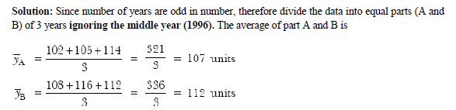
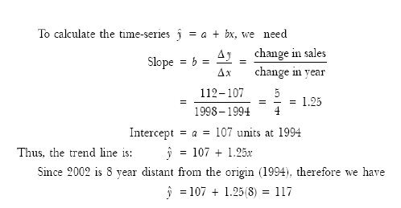
C. The data on prices (Rs in per kg) of a certain commodity during 2000 to 2004 are shown below: 10 marks
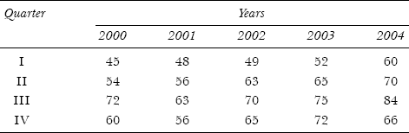
Compute the seasonal indexes by the average percentage method .

Calculation Seasonal Indexes
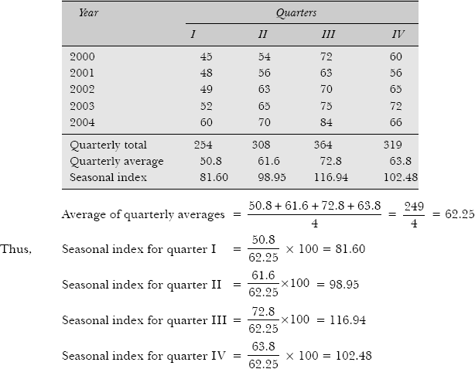

Part B: Case study – Compulsory (10 Marks)
(c) Raju Restaurant near the railway station at Falna has been having average sales of 500 tea cups per day. Because of the development of bus stand nearby, it expects to increase its sales.
During the first 12 days after the start of the bus stand, the daily sales were as under:
550, 570, 490, 615, 505, 580, 570, 460, 600, 580, 530, 526
On the basis of this sample information, can one conclude that Raju Restaurant’s sales have increased?
Use 5 per cent level of significance. (For 11 dof table value T is 1.796)

